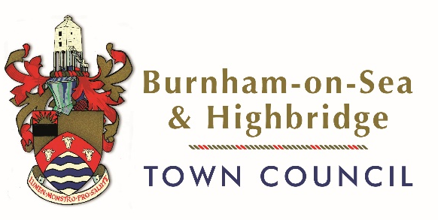
PRECEPT CONSULTATION
As residents will have seen in the media, Somerset Council are facing enormous financial challenges and are having to make some difficult decisions about services it provides.
The Town Council has been asked to consider taking over/funding some of the services that Somerset Council will no longer be able to fund.
For the Town Council to be able fund any additional service, it will have to significantly increase its budget and Precept request, which will increase residents Council Tax payments.
The Town Council is holding a consultation to understand what residents’ priorities are, so the information can be considered when Councillors make a final decision on what services to help fund/manage. The Town Council is unlikely to be able to cover all the service costs, so the community’s views are vital.
If you were unable to attend one of the drop-in sessions please complete the form below and return to info@burnham-highbridge-tc.gov.uk or to The Old Courthouse, Jaycroft Road, Burnham-on-Sea, TA8 1LE by Midday on 19th December 2023. Forms received after this date will not be considered.
Please mark THREE most important service areas you would like to see continued;
 | SERVICE AREA | EXAMPLES | PLACE X AGAINST 3 SERVICE AREAS
1. | TRANSPORT | Community Transport and Bus Services funding
2. | HIGHWAYS | Removing litter from verges, grit bin replacement, verge maintenance, vegetation clearance and cutting on the Rights of Way network, minor Highways functions such as footway and footpath repairs, ditches and grips clearance, hedge trimming, signage for new or changed speed limits, non-illuminated sign cleaning and maintenance, planned path safety inspections, low tech preventative maintenance functions
3. | PUBLIC TOILETS | Public toilets, provision and opening hours – Apex Park, Esplanade and Oxford Street
4. | STREET SCENE | fly tipping, street cleaning, provision and collection of litter bins, carnival clean-up, bedding planting, memorial maintenance
5. | OPEN SPACES | Management and maintenance of open spaces assets - including both green spaces as well as “hard” open spaces, grass cutting and open space maintenance, local parks, maintenance and installation of play areas, maintenance of sports grounds
6. | TOURISM | Tourist Information Centre
7. | COMMUNITY RESILIENCE | Provision of sandbags/gel bags

The Town Council currently provides the following services. Which are important to you?
 | SERVICES PROVIDED | PLACE X AGAINST IMPORTANT SERVICES
1. | Town Christmas lights
2. | Annual fireworks event
3. | Princess Theatre
4. | Dog bin provision
5. | Civic Events
6. | Grants to community groups
7. | Events inc Remembrance Parade
8. | Climate & Ecology
9. | Floral Displays (hanging baskets etc)
10. | Public toilets
11. | Other – please state

The consultation is only open to residents of Burnham-on-Sea and Highbridge Parish, so please ensure you provide your details below.

Initial…………………………………………………………………………………………
Surname…………………………………………………………………………………….
Address inc postcode………………………………………………………………………
………………………………………………………………………………………………..
………………………………………………………………………………………………..

Your data will only be used in relation to the consultation. Data will be held in accordance to the Town Councils’ Privacy Policy. Further details are available on the website www.burnham-highbridge-tc-gov.uk

